

Fig1 :- Represents the Front End login page

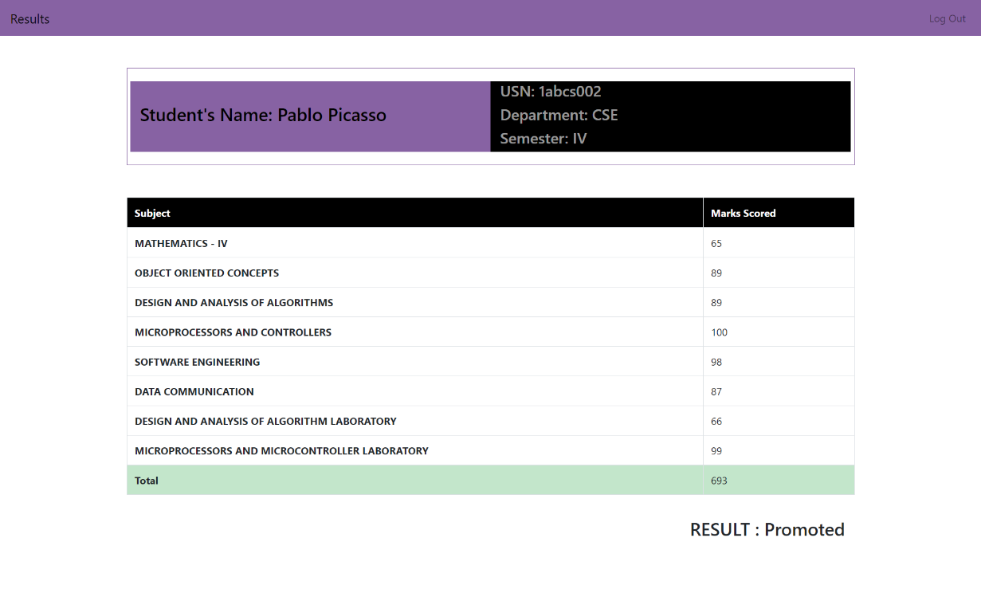

Fig2 :- Represents the Front End result page



Fig3 :- Represents the Back End Faculty login page

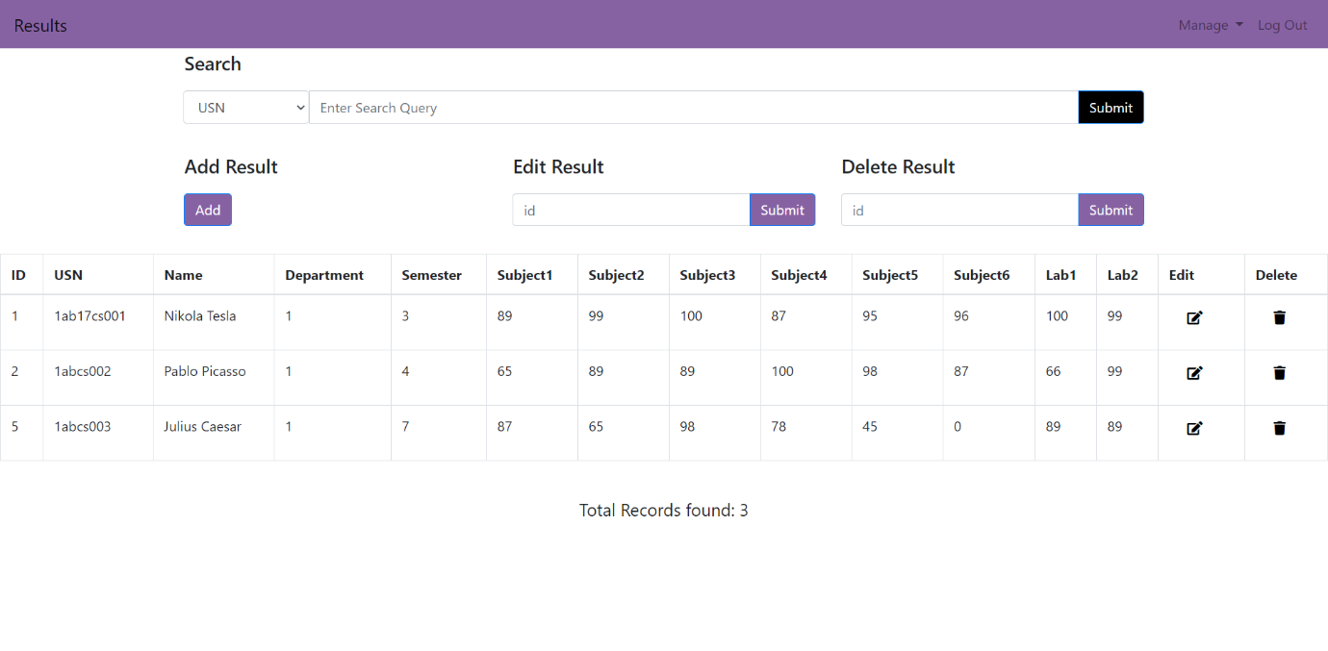

Fig4 :- Represents the Student result management Page

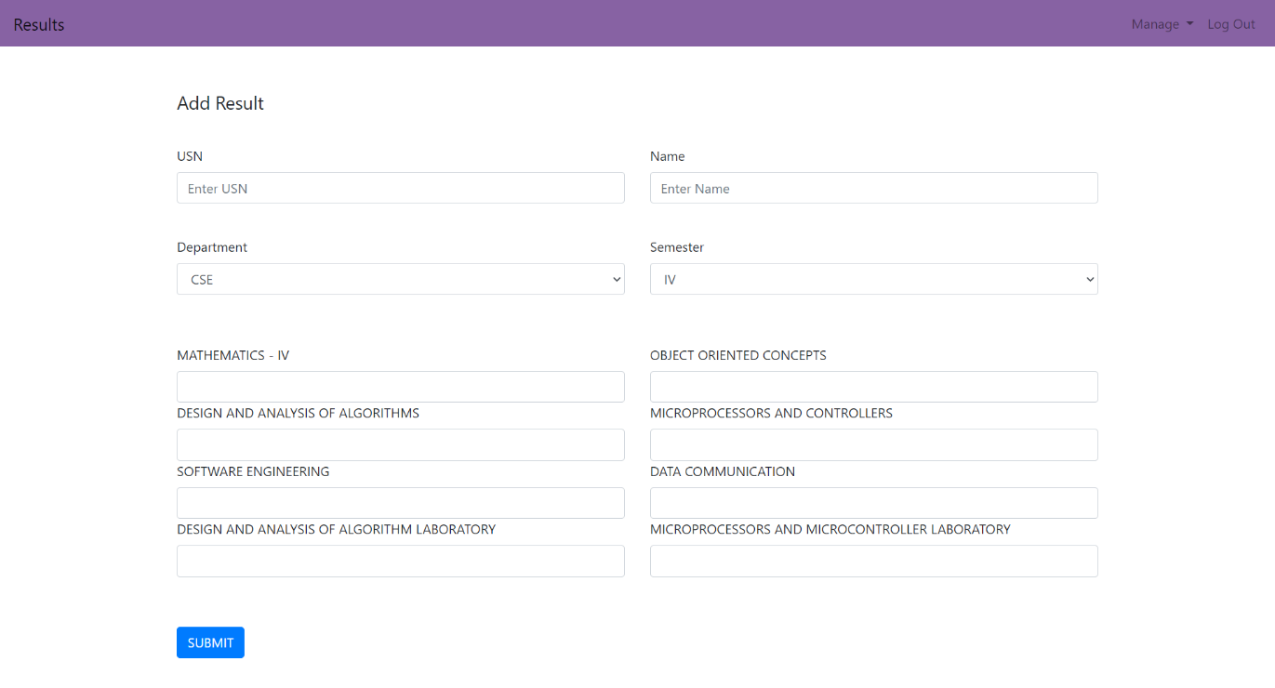

Fig5 :- Represents the Student result add page

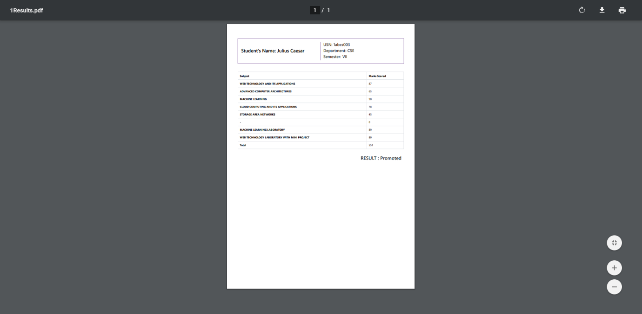

Fig6 :- Represents the Downloaded result pdf page